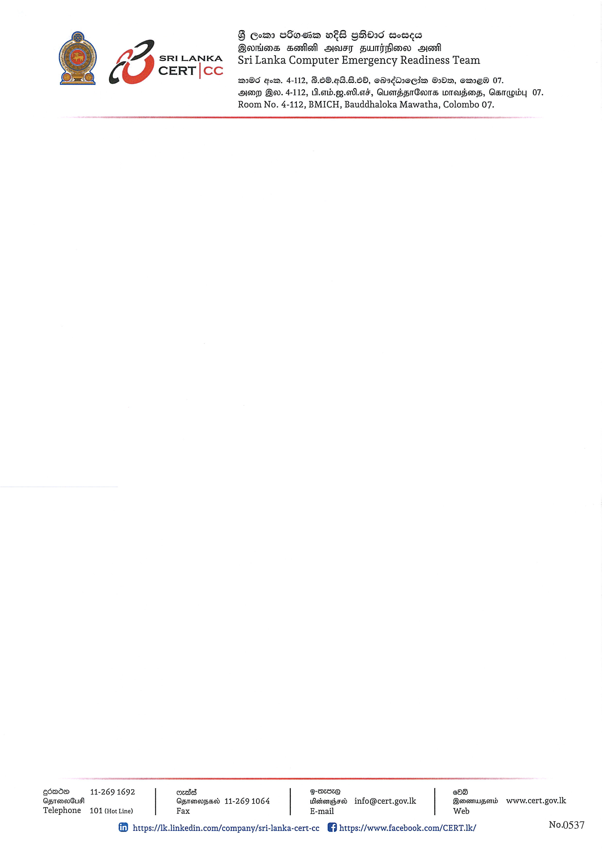

16.03.2026
Press Release
Sri Lanka CERT Conducts Cyber Safety Awareness Program for Members of Parliament
The Sri Lanka Computer Emergency Readiness Team (Sri Lanka CERT) conducted a Cyber Safety Awareness Program for the Members of Parliament of Sri Lanka, with the objective of enhancing awareness on the secure and responsible use of digital technologies, particularly in the context of national governance.
In an era where digital platforms play a critical role in governance, policymaking, and public communication, the importance of cybersecurity for parliamentarians cannot be overstated. As key decision-makers with access to sensitive information and national systems, Members of Parliament can be exposed to cyber threats such as phishing, data breaches, and misinformation campaigns. Strengthening their awareness and preparedness is therefore essential to safeguarding national security and maintaining public trust.
The awareness program was attended by Deputy Speaker Hon. Dr. Rizvie Salih and along with Deputy Chairperson of Committees Hon. Hemali Weerasekere and several government and opposition members.
The programme covered several critical areas, including cyber hygiene, secure online communication practices, and cybersecurity best practices required to operate safely within an increasingly interconnected digital environment.
The event featured remarks by Mr. Waruna Sri Dhanapala, Secretary to the Ministry of Digital Economy. Mr. Tilak Pathirage, Chairman of Sri Lanka CERT. Dr. Kanishka Karunasena, Acting Executive Officer of Sri Lanka CERT, also addressed queries raised by the Members of Parliament.
The technical sessions were conducted by Mr. Nirosh Ananda, Chief Information Security Officer of Sri Lanka CERT, and Mr. Charuka Damunupola, Lead Information Security Engineer, and Thilina Dissanayake, Program Manager - Capacity Building at Sri Lanka CERT. The sessions provided practical guidance on identifying cyber threats, safeguarding both personal and official digital communications, and adopting secure online behaviours.

Members of Parliament actively engaged with the resource persons throughout the programme, reflecting a strong interest in strengthening their understanding of cybersecurity. Their participation underscored the growing recognition of cybersecurity as a critical component of effective governance and public service.
Sri Lanka CERT continues to play a leading role in enhancing national cybersecurity resilience through targeted training and awareness programmes for both public and private sector stakeholders.

